Core idea:

When a philosopher puts a fork down, they call V() on the condition semaphore of their neighbor, who eventually wakes up “with the forks in their hands”

Result:

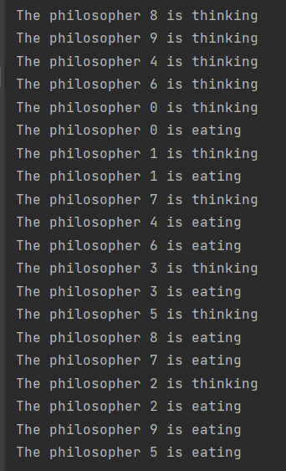

Code:

Note: There are 10 philosophers. The id varies from 0 to 9.

|  |
| --- |
| public class philosopher_solution {  static int *THINKING* = 0;  static int *HUNGRY* = 1;  static int *EATING* = 2;  static int *N*=10;  static int []*state*=new int[*N*];  static Semaphore []*c*=new Semaphore[*N*];  static Semaphore *mutex* = new Semaphore(1);   public static void get_forks(int i) throws InterruptedException {  *mutex*.P();  *state*[i] = *HUNGRY*;  *test*(i);  *mutex*.V();  *c*[i].P();  }  public static void put_forks(int i) throws InterruptedException {  *mutex*.P();  *state*[i] = *THINKING*;  *offer_fork*(i==0?*N*-1:i-1);  *offer_fork*(i==*N*-1?0:i+1);  *mutex*.V();  }   public static void test(int i) { /* called under mutex conditions */  if (*state*[i==0?*N*-1:i-1] != *EATING* && *state*[i==*N*-1?0:i+1] != *EATING*) {  *state*[i] = *EATING*;  *c*[i].V();  }  }  public static void offer_fork(int i) {  if (*state*[i] == *HUNGRY* && *state*[i==0?*N*-1:i-1] != *EATING* && *state*[i==*N*-1?0:i+1] != *EATING*) {  *state*[i] = *EATING*;  *c*[i].V();  }  }   public static void main(String[] args) throws InterruptedException {  for (int i = 0; i < 10; i++) {  *c*[i]=new Semaphore(0);  }  for (int i = 0; i < 10; i++) {  Philosopher ph = new Philosopher(i);  ph.start();  }  } } class Semaphore{  private int count;  public Semaphore(int n){  count=n;  }   public synchronized void P() throws InterruptedException {  count--;  if(count<0)  wait();  }   public synchronized void V(){  count++;  if(count<=0)  notify();  } } class Philosopher extends Thread{  int id;   public Philosopher(int i) {  id=i;  }   @Override  public void run() {  for(int i=0;i<1;i++) {  think();  try {  philosopher_solution.*get_forks*(id);  } catch (InterruptedException e) {  throw new RuntimeException(e);  }  eat();  try {  philosopher_solution.*put_forks*(id);  } catch (InterruptedException e) {  throw new RuntimeException(e);  }  }  }   public void think(){  System.*out*.println("The philosopher "+id+" is thinking");  }   public void eat(){  System.*out*.println("The philosopher "+id+" is eating");  } } |